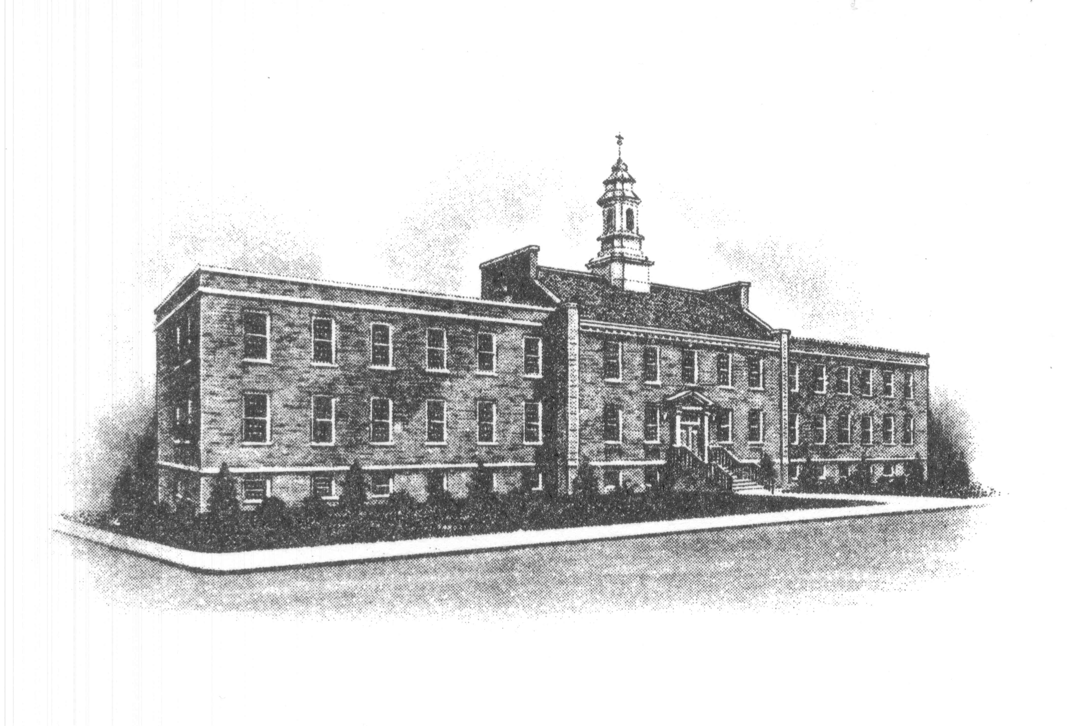
Sayreville Economic and
Redevelopment Agency
167 Main Street
Sayreville, NJ 08872
732-390-7010

January 8, 2024

Please be advised that the Sayreville Economic Redevelopment Meeting will be held on the original scheduled date of
January 25, 2024.

Please disregard the meeting change date previously noticed for Thursday, January 18, 2024.

The meeting January 25, 2024 will be held in Room 308 at the main Borough Hall beginning at 6:30 PM.

If there are any questions you can contact Joan Kemble, Secretary at 732-390-7077.

