**PLEASE SEND COMPLETED FORMS TO:** [**ggawron@sayreville.com**](mailto:ggawron@sayreville.com)

**Contact Information:**

Private Community/Property: Name:________________________________________________________

Responsible Party Name:_______________________________Title:_______________________

Phone Number: ______________________________________Email:______________________

**Total Number of Storm Drains in Private Community / Commercial Property / Industrial Complex / Private Property (as it pertains to you) : ______________**

**Storm Drain Inspection / Cleaning (catch basins) date: _____________**

**Storm Drain Inlet Retrofitting**

Have your storm drains on your property been retrofitted and in compliance with the

Borough of Sayreville’s Ordinances? ________________

If not, when do you expect to have this completed? ___________________________

**Retention Ponds and Swales**

Do you have swales on your property? ________________

Have they been inspected and maintained? ________________

Do you have retention ponds on your property? ________________

Have they been inspected and maintained? ____________________

**Refer to the following page for visuals and descriptions.**

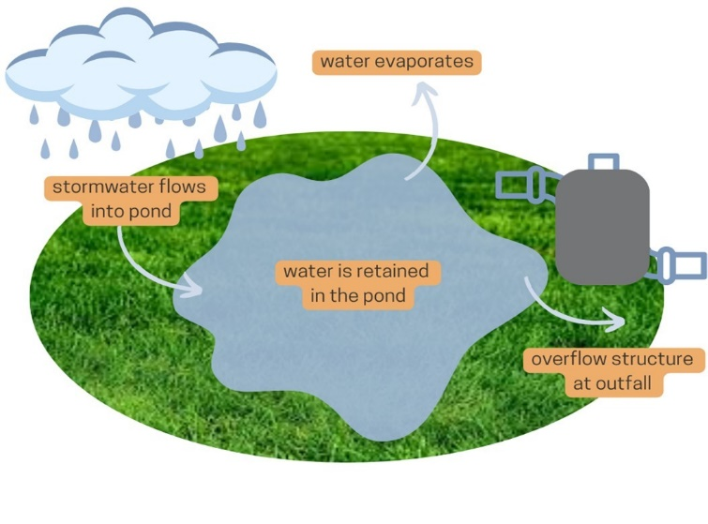**Retention Ponds**

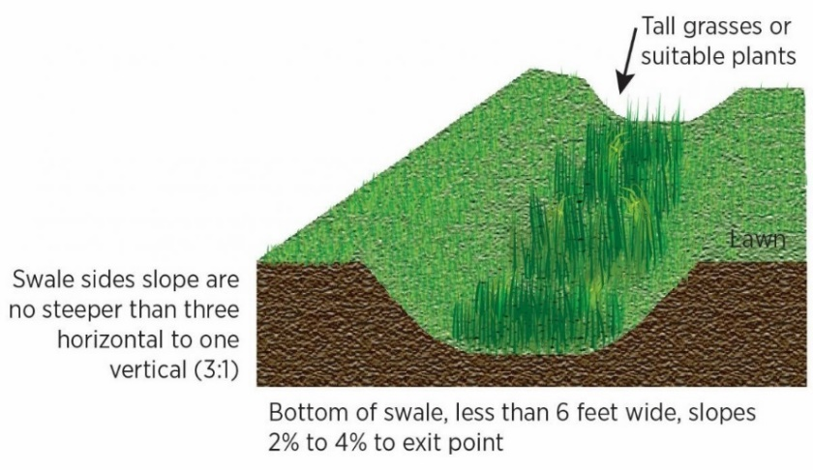**Swale**

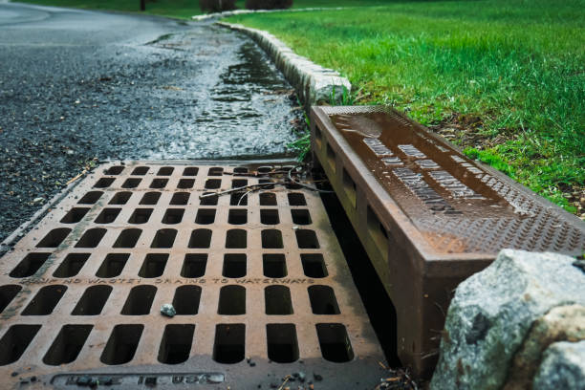 retrofitting

A "retrofit" for a storm drain or catch basin refers to modifying an existing storm drain or catch basin structure to improve its functionality by modifying outlet structures, essentially upgrading an older drainage system to meet current environmental standards.