**EASY THINGS YOU CAN DO EVERY DAY TO PROTECT OUR WATER**

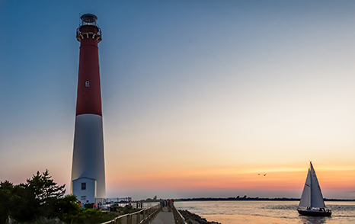

**A GUIDE TO HEALTHY HABITS FOR CLEANER WATER**

Pollution on streets, parking lots and lawns is washed by rain into storm drains, then directly to our drinking water supplies and the ocean and lakes our children play in. Fertilizer, oil, pesticides, detergents, pet waste, grass clip­pings: You name it and it ends up in our water.  
Stormwater pollution is one of New Jersey's greatest threats to clean and plentiful water, and that's why we're all doing something about it.  
By sharing the responsibility and making small, easy changes in our daily lives, we can keep common pollutants out of stormwater. It all adds up to cleaner water, and it saves the high cost of cleaning up once it's dirty.  
As part of New Jersey's initiative to keep our water clean and plentiful and to meet federal requirements, many municipalities and other public agencies including colleges and military bases must adopt ordinances or other rules prohibiting various activities that contribute to stormwater pollution. Breaking these rules can result in fines or penalties.

**As a resident, business, or other member of the New Jersey community, it is important to know these easy things you can do every day to protect our water.**  
  
**LIMIT YOUR USE OF FERTILIZERS AND PESTICIDES  
  
PROPERLY USE AND DISPOSE OF HAZARDOUS PRODUCTS  
  
KEEP POLLUTION OUT OF STORM DRAINS  
  
CLEAN UP AFTER YOUR PET  
  
DON'T FEED WILDLIFE  
  
DON'T LITTER  
  
DISPOSE OF YARD WASTE PROPERLY**  
  
**CONTACT INFORMATION**  
For more information on stormwater related topics, visit [www.njstormwater.org](http://www.njstormwater.org/) or www. nonpointsource.org  
Additional information is also available at U.S. Environmental Protection Agency Web sites:  
 <http://www.epa.gov/nps/>