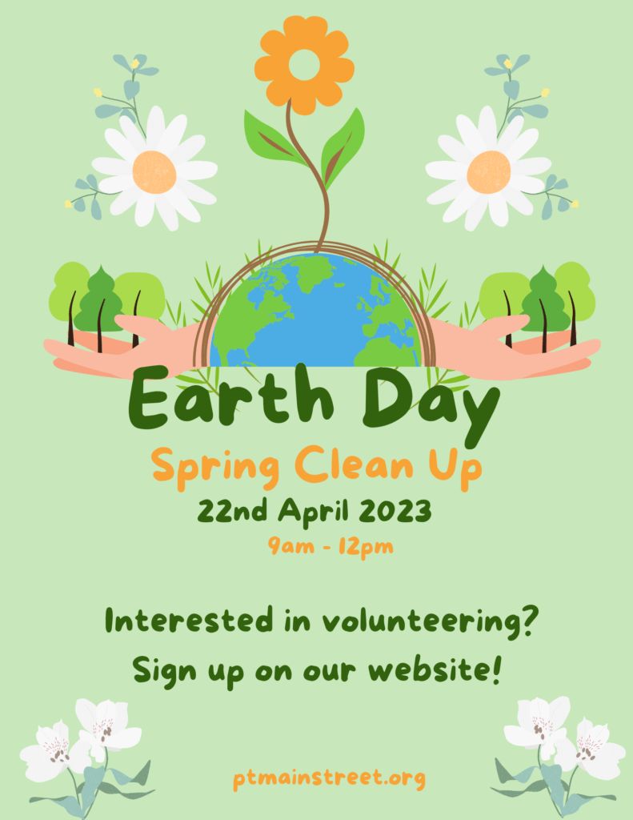
PRIDE IN OUR COMMUNITY
EARTH DAY 2024
Arbor Day

Earth day is intended to inspire awareness and appreciation for the Earth’s natural environment. Earth day was founded by United States Senator Gaylord Nelson as an environmental teach-in, first held on April 22, 1970. Earth Day is now coordinated globally and is celebrated in more than 175 countries every year by more than 500 million people.
JOIN US
On Saturday, April 20th
Kennedy Park 9:00 – 12:00
Rain Date Saturday, May 4th 9:00 – 12:00

Sayreville Clean Communities, Environmental Commission and the Shade Tree Commission, along with community volunteers and civic groups will be celebrating Earth Day at Kennedy Park.

Free seedlings
Arbor Tree Planting & a Memorial Tree Planting
Informational tables including the Community Garden
Giveaways
Free t-shirts for the first 100 people
recycling@sayreville.com

Earth Day 2024 provides an opportunity for all of us to do something meaningful for our planet and our communities. We encourage you to join us on this important occasion, to do your part to restore and care for the places where we live, work, and play for this and future generations.

