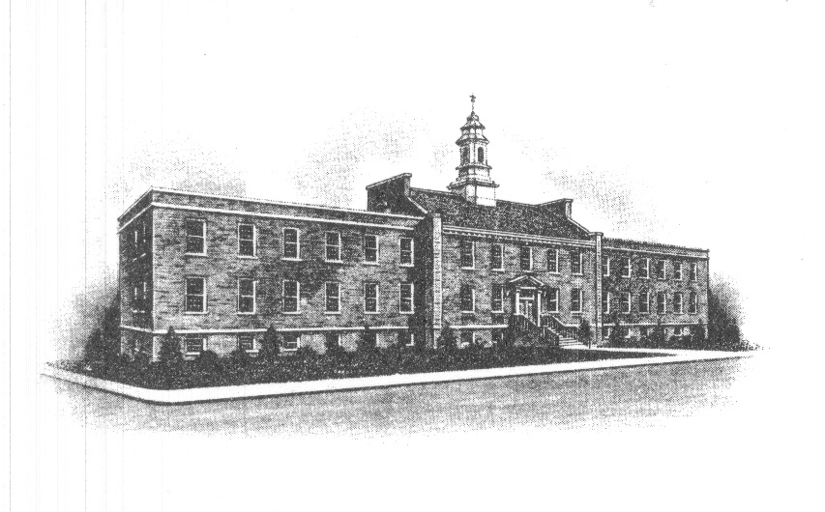
The Borough of Sayreville
Sayreville Board of Adjustment
167 Main Street
Sayreville, NJ 08872
(732) 390-7077 - Phone
(732) 390-7458 - Fax

BOROUGH OF SAYREVILLE
NOTICE OF IN-PERSON MEETINGS OF THE
ZONING BOARD OF ADJUSTMENT

Please be advised that the Zoning Board of Adjustment of the Borough of Sayreville, N.J., will resume holding its regularly scheduled and previously noticed meetings in-person and will no longer conduct meetings via electronic communications equipment (by Zoom/telephone). In-person meetings will commence with the November 23, 2021 meeting and will continue for all meetings for the remainder of the 2021 calendar year and at which meetings formal action may be taken. The in-person meetings will be held in the Council Chambers in Borough Hall, 167 Main Street, Sayreville, NJ 08872.

All persons attending in-person meetings shall adhere to Borough COVID guidelines including: wearing a mask to enter the building and for the duration of the meeting, sitting in designated benches (every other row) and sitting in designated seating areas (every six feet).

If you wish to review the file for an application, please contact the Board Secretary, Joan Kemble at (732) 390-7077 or by email at: joank@sayreville.com to schedule a time. Additionally, the Board’s Agenda and application documents can be accessed through the “Meetings” page on the Borough website, at: http://www.sayreville.com.

Joan M. Kemble
Secretary
Zoning Board of Adjustment

