Use Plastic Bags
to make your own flowers
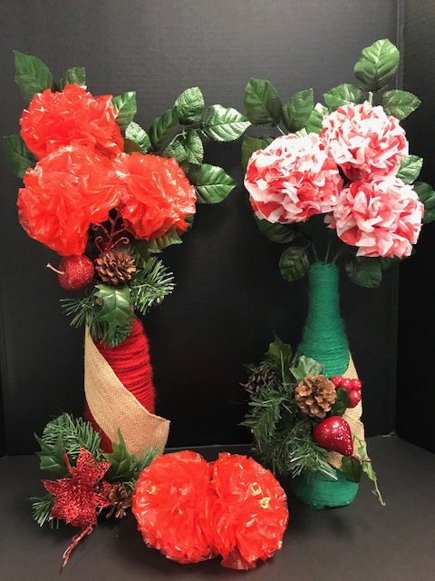
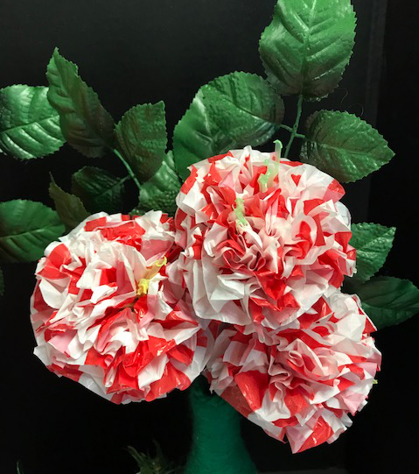

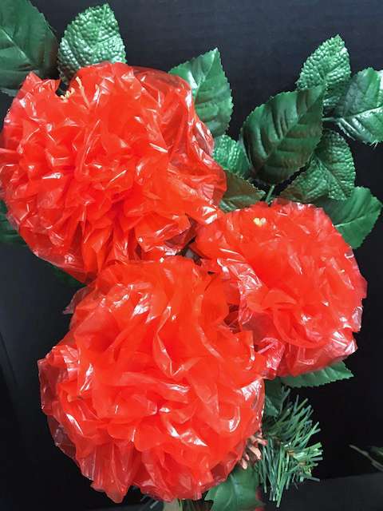

Equipment for the flowers
Plastic bags - wire - straw - scissors - ruler - rubber bands

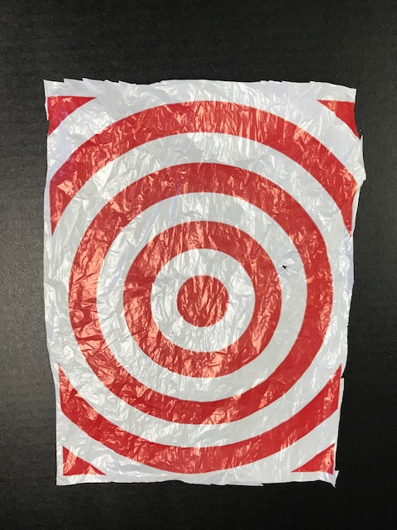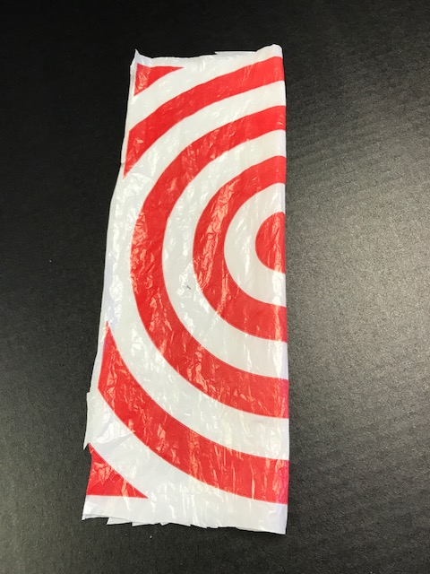

Flatten the bag and cut down both sides
Fold over and cut into strips - width 4 inches each
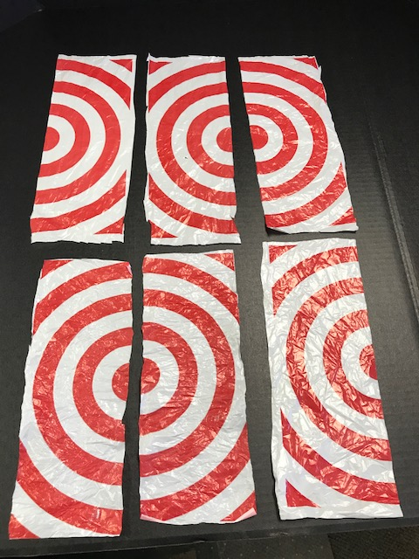
You should have 6 strips altogether

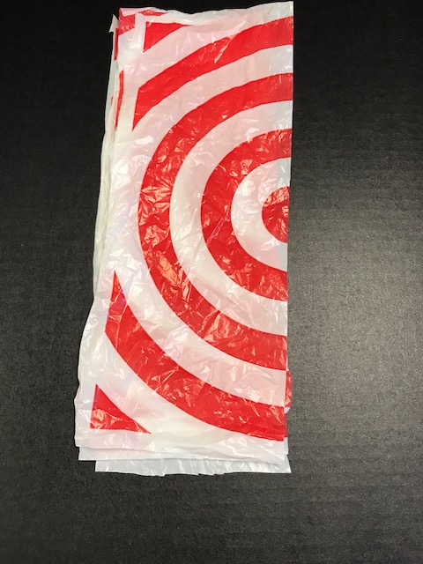
Line up the edges of all the sheets and lay flat on a surface

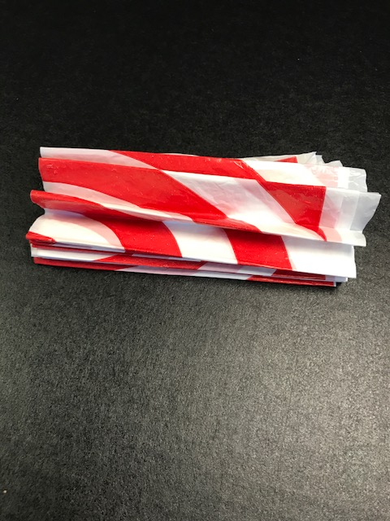
Fold about 3/4 inch and keep going back and forth accordion style
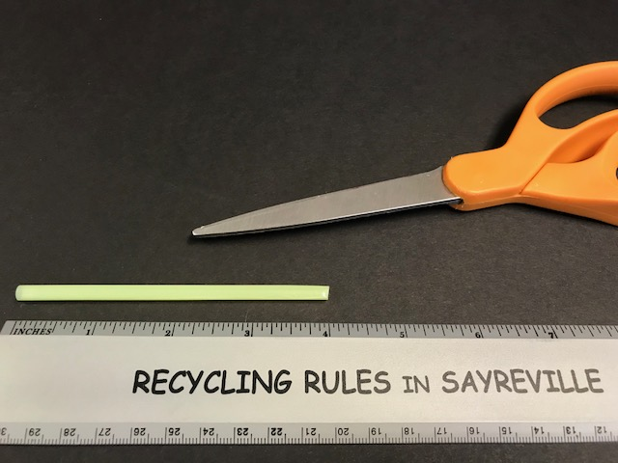
Nest cut a straw 4 inches long
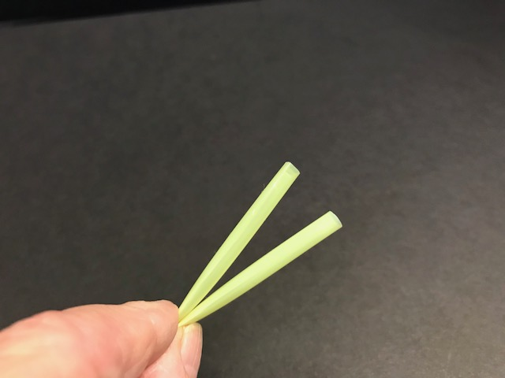
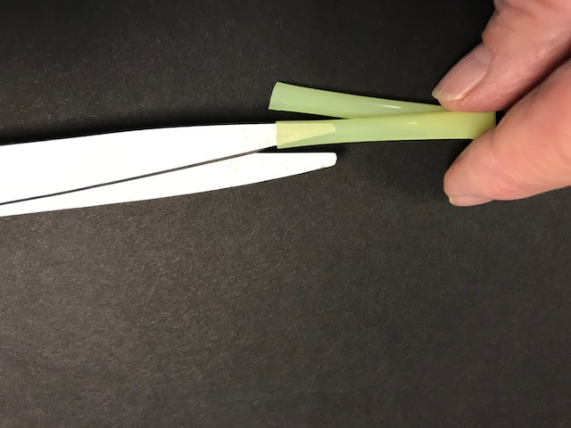
Fold in the middle and then cut both ends into thin strips
leaving 1/2 inch in the middle
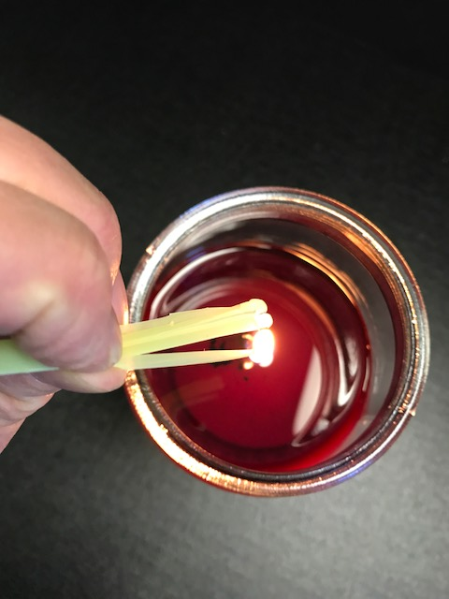

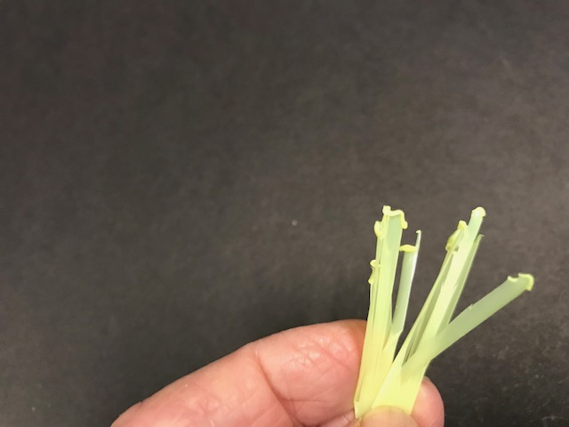
Carefully burn the tip of each strip over a candle
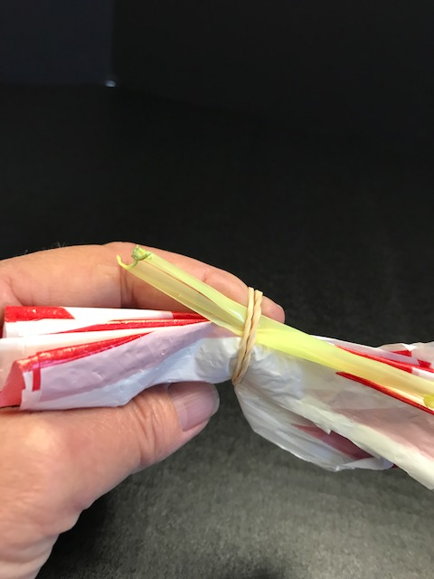
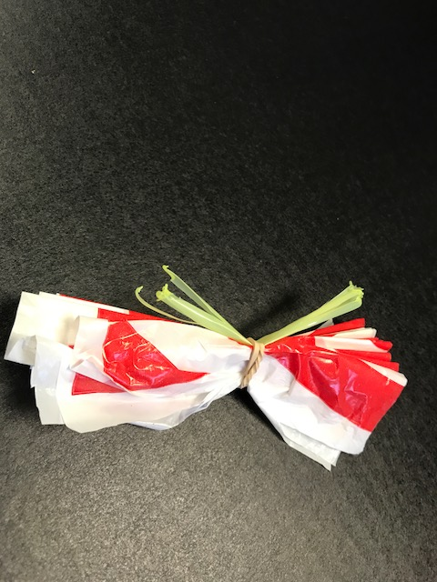
Put the straw stamen on top and then tie with wire or rubber band around the middle. Make sure it is in the center
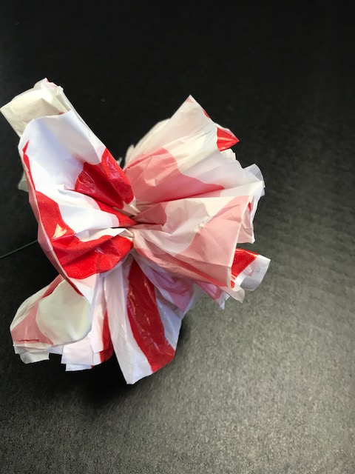

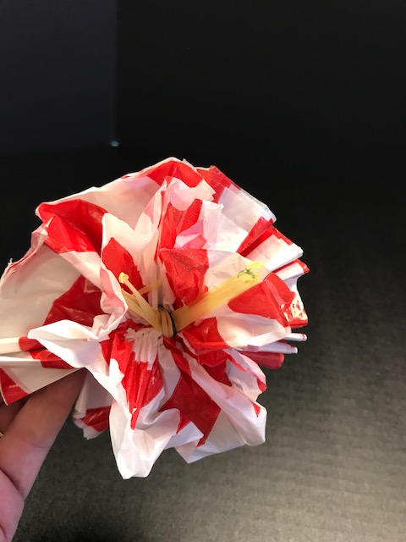
Open to form a circle and pull upward to separate all the layers
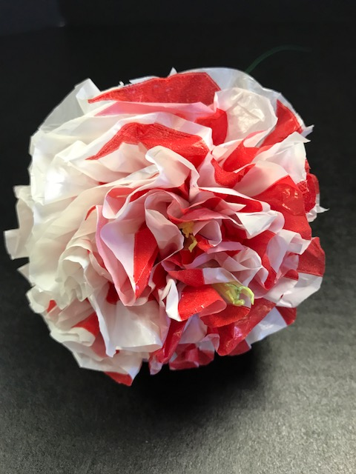
Trim
and that's it!

Reduce - REUSE - Recycle - Repurpose

