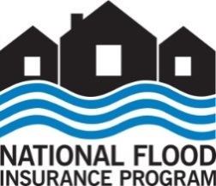
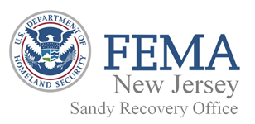

September 23, 2015
SRO NJ NR 58
FEMA News Desk: 877-434-4084

News Release
Last Day to Request a Review of Hurricane Sandy Flood Insurance Claims is Three Weeks Away

Three weeks remain for National Flood Insurance Program (NFIP) insurance policyholders to submit their Hurricane Sandy Claims for review by the Federal Emergency Management Agency. The last day to submit claims is Thursday, Oct. 15, 2015.

The U.S. Department of Housing and Urban Development recently announced that any additional flood insurance proceeds up to $20,000 will not be treated as duplicative, and will not be recouped by HUD or its grantees. To date, approximately three out of four NFIP claimants have received less than $20,000 in additional compensation from FEMA, and will not face any possible repayment of HUD-funded grants.

Policyholders can call the NFIP’s Hurricane Sandy claims center at 866-337-4262 from 8 a.m. to 8 p.m. Eastern Daylight Time (EDT), Monday through Friday, to request a review. It is important to have your policy number and insurance company name ready when you call. As of Sept. 16, more than 14,000 policyholders have requested reviews of their Sandy flood insurance claims.

Policyholders also can go online to www.fema.gov/hurricane-sandy-nfip-claims to download a form requesting a review. The downloaded form can be filled out and emailed to FEMA-sandyclaimsreview@fema.dhs.gov or faxed to 202-646-7970 to begin the review process. For individuals who are deaf, hard of hearing, or have a speech disability and use 711 or VRS, please call 866-337-4262. For individuals using a TTY, please call 800-462-7585 to begin the review process.
###
FEMA's mission is to support our citizens and first responders to ensure that as a nation we work together to build, sustain and improve our capability to prepare for, protect against, respond to, recover from and mitigate all hazards.
Follow FEMA online at www.fema.gov/blog, www.twitter.com/fema, www.facebook.com/fema and www.youtube.com/fema.
Also, follow Administrator Craig Fugate's activities at www.twitter.com/craigatfema.The social media links provided are for reference only. FEMA does not endorse any non-government websites, companies or applications.

