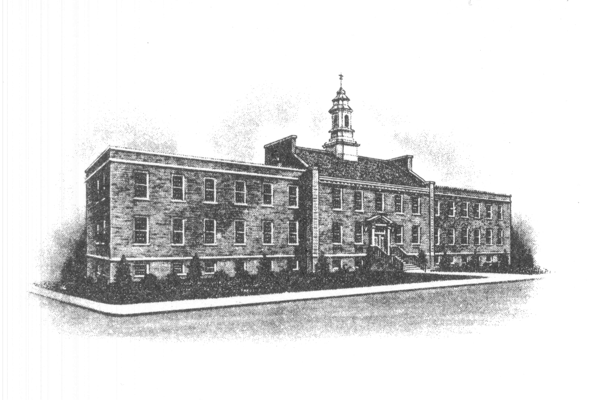
The Borough of Sayreville
Zoning and Code Enforcement
49 Dolan Street
Sayreville, NJ 08872

APPLICATION FOR RENTAL COMPLIANCE CERTIFICATE

Inspection Date and Time: _________________

Date of Rental: ____________

Certificate # Date

Owner Information

Property Address

Building Number _______________________ Apartment Number _________________

Owner’s Name Phone:

Address

Name On Lease __________________________________________________________

Number of Occupants __________________ Phone: __________________________

Realtor’s Name _______________________ Phone: __________________________

Dwelling Details

Total # of Rooms # of Bedrooms # of Bathrooms

Type of Heat Is There a Garage? __ If Yes, # of Cars ____

Is this a basement apartment? Y / N Is this an attic apartment? Y / N

Is there any special condition that this department should be made aware of prior to the inspection?

If so, please specify

Date Applicant’s signature

Please arrive 15 minutes prior to the scheduled inspection time.

Fee schedule is as follows:

- $75.00 scheduled more than 5 business days from date of rental
-Additional re-inspections, if needed, will be $50 each
2. $125.00 scheduled 5 business days or less from date rental
– Re-inspection fee shall be $75.00

FEES MUST BE PAID AT THE TIME OF APPLICATION FILING. CHECKS OR MONEY ORDERS ARE TO BE MADE PAYABLE TO:

THE BOROUGH OF SAYREVILLE

IF PAYING BY CREDIT CARD WE ACCEPT VISA OR MASTERCARD.

FOR DEPARTMENT USE ONLY:

Application processed by:

Type of Payment (Checks, Credit Card, Money Order) Check #

Amount Paid _____

OPEN PERMITS: _____________________________________________________

_______________________________________________________________________

Additional Comments

